**Jc340203 Mandeep Kaur Pandher**

**Project Plan:**

**Goals**

* Adorable looks for the little ones.
* Offers a wide range of clothes and accessories for baby boys and girls.
* To keep our customers informed for the latest stocks.
* Attract more customers by providing offers.
* Satisfy the needs of pregnant mothers and mothers at one place.

**Success Evaluation**

* **Consumption metrics: -** Page view metrics track how many people visit the website. This is the easiest way to evaluate the success of a website.
* **Sharing metrics: -** By using these metrics we measure how many people are sharing the website on web. So these metrics are good and useful indicators of the website’s performance.
* **Usability: -** See how usable the site is? How long does the website take to load the pages? All these things needs to be take care for the evaluation of a website.
* **Style :-** To test the effectiveness of the website consider the following things:
* Will the style suit the target audience?
* Will the best design align with their brands, create positive impression for visitors and be clean?

**Target audience**

* The target audience of my website is pregnant mothers and baby girls & boys.

**Flow Chart**

**Home**

**Home**

**Different Wears**

**Contact**

**Registration**

**Footwear’s**

**Registration form**

**Girls Wears**

**Baby Girls Footwear’s**

**Boys Wears**

**Baby Boys Footwear’s**

***Home Page***

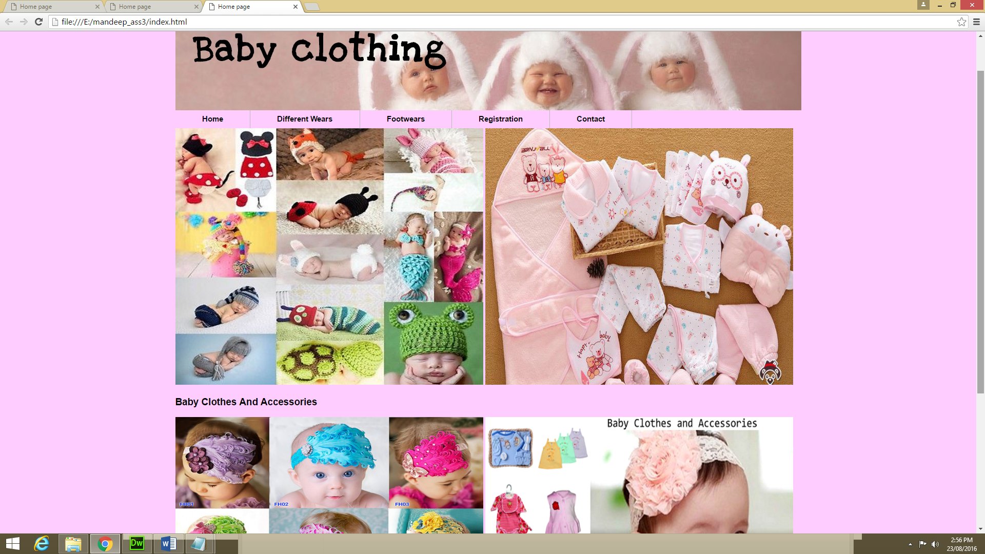

***Different Wears***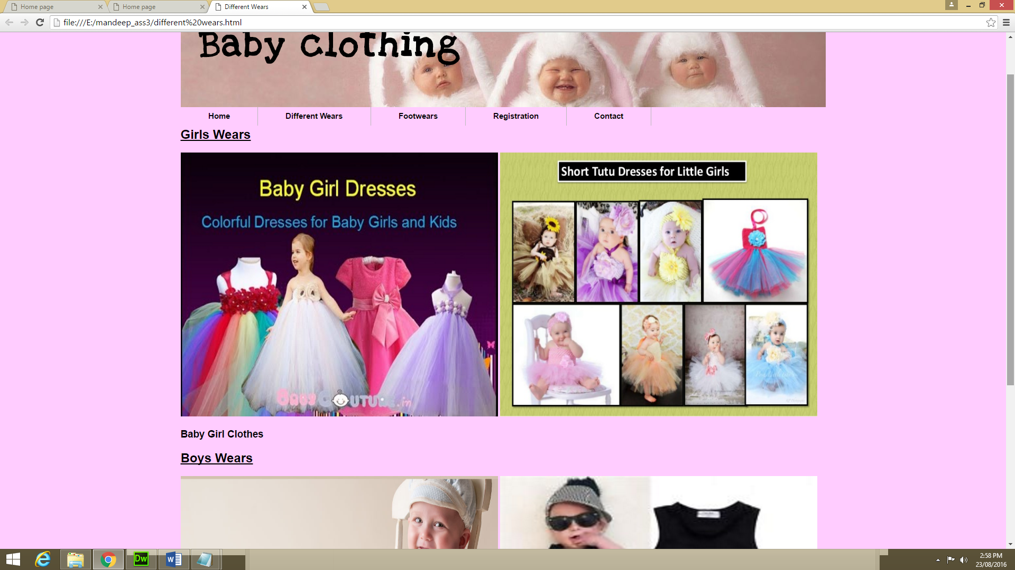

***Foot Wears***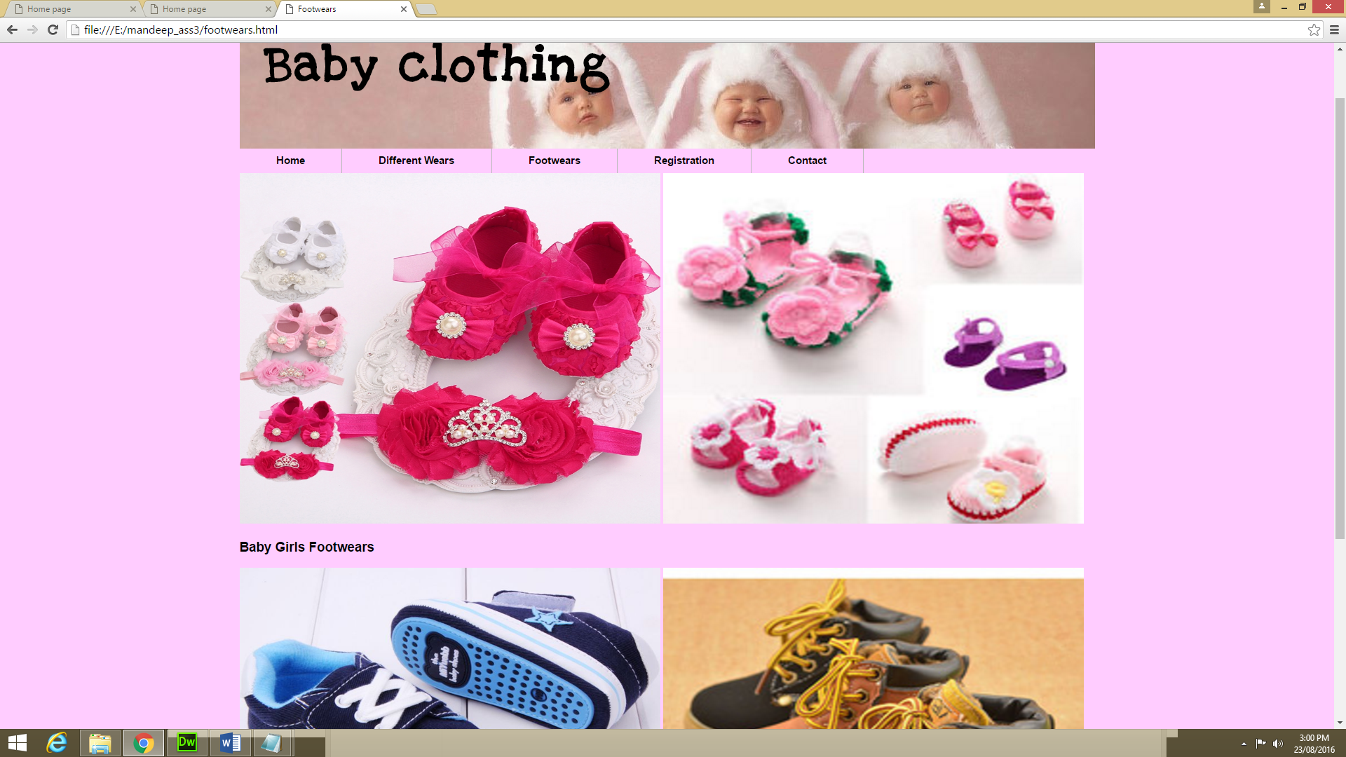

***Registration***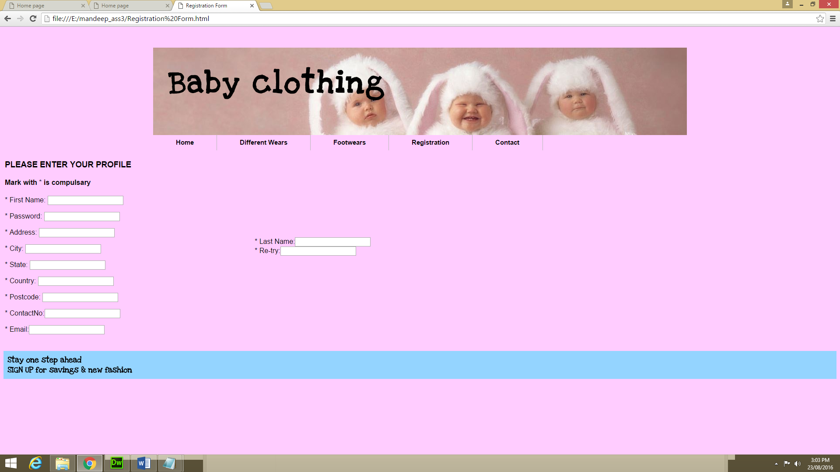

***Contact***